**CHAPTER 4**

**University of San Carlos Audio Visual Reservation and Asset Management System’s**

**Software Development**

**4.1 Requirement Specification**

This Section will describe the business flow, different interfaces, assumption and dependencies, constraint and the specific requirement of the project

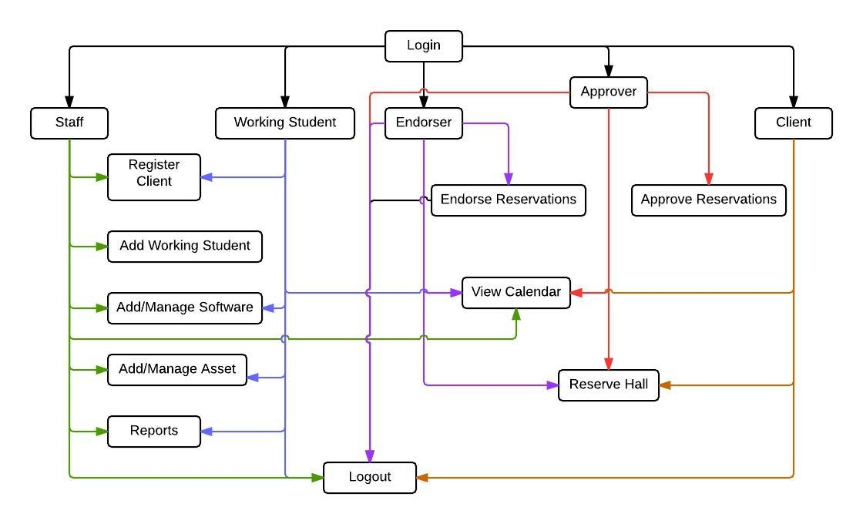 **4.1.1 Business Process Flow**

***Figure 4.1.1.1 Business Process Flow***

**4.1.2. System Interfaces**

As the developers gathered date and have seen in the business flow of the audio visual center, there are parts that can be automated.

The modules for our system are:

Login

* This module where the clients, approver, endorser, working student, and staff will input each username and password according their accounts.

Software Item

* This module has the record of each software materials found in the Audio Visual Office. It can add software materials and update the information of the materials. It can change the status of the materials if it is available or borrowed.

Asset Item

* This module has the record of assets found in the Audio Visual Office. It can add update the information of the assets.

Working Student

* This module has the record of working student found in a specific Audio Visual Office in the campus. It can add update the information of the working student.

Calendar

* This module displayed the reserved time and dates of all the halls in the university. It can be viewed weekly and monthly

Register

* This module registered different clients in the system. Client in the system can be a faculty, student or employee. The staff and working has the power to register these users.

Reservation

* This module reserved clients preferred time and date in using a hall.

Statistical Report

* This module generates the statistical data of the usage of the hall.

Endorser

* This module views the reservation form that need to be endorsed. This is where the reservation appears after submitting the form

Approver

* This module views the reservation form that need to be approved. This is where the reservation appears after it is being endorsed.

**4.1.3 User Interfaces**

The system provides login module where the staff, working student, approver, endorser, clients input their specific username and password. The staffs, working students, approvers, endorsers, clients have different module when they logged in. The staff can access all the modules except reservation, working student can also access some modules except reservation and working student, endorser can only access the reservation, calendar and endorser module, approver can only access the reservation, calendar and approver module, clients can only access the reservation and calendar module.

**4.1.4 Hardware Interfaces**

This section covers the different hardware we have used in order for the system to work.

**Table 4.1.4.1 Hardware Interfaces**

|  |  |
| --- | --- |
| Name | Purpose |
| **Desktop Computer/ Laptop** | To access the different modules in the system |
| **Internet Connection** | In order for the system to work online |
| **Printer** | To print the statistics that is needed by the staff. |

**4.1.5 Software Interfaces**

This section covers the different software we have used so far for this system and additional plug-ins that allowed it to work.

**Table 4.1.5.1 Software Interfaces**

|  |  |  |  |
| --- | --- | --- | --- |
| Name | Version No. | Source | Purpose |
| **Xampp** | **V3.2.1** | http://sourceforge.net/projects/xampp | Interprets the scripts written in PHP and includes the SQL Database manipulation and uploading through Filezilla |
| **PHP** | **PHP 5.6.0** | http://php.net/ | All-purpose programming |
| **Bootstrap** | **V3.2.0** | http://getbootstrap.com/ | To apply simple design and interior security checks(e.g. Pattern) |
| **Google Chrome** | **Version 37.0.2062.120** | https://www.google.com.ph/chrome/browser/ | For research purposes and used to adjust display for our website. |
| **Code Igniter** | **V2.2.0** | http://www.codeigniter.com/ | Used this PHP framework for efficient coding. |

**4.1.6 Communication Interfaces**

This project can be shown in the library system since the Audio Visual Center is under the library system and it can be access either outside or inside the university. The head and staff of each Audio Visual Center have an access with the system in order to manage the system. Another is the director of library system also needs to have an access so that he can view the reservation and statistics of the reservation system for some reasons. The director of the library system can’t edit and add software materials or assets. The director can only reserve a hall and reset the entire datum in the database

**4.1.7 User characteristics**

There are five user rights for this system namely the Staff, Working Student, Approver, Endorser and the Client. The user side has all the rights of the system because he is the on managing it. The Working Student side has almost all the right except adding the working student. The approver can only approve reservations, view the availability and reserve hall. The endorser can only endorse reservations, view the availability and reserve hall. The client can only view the availability and reserve halls.

**4.1.8 Assumptions and dependencies**

In implementing the system, develops must know some of the assumptions and dependencies of the system to avoid problems in implementing it.

**Assumptions:**

* The clients should be faculty, student or employee in the University of San Carlos
* The users should have a sufficient knowledge of computers
* There must have an internet connection in accessing the system.

**Dependencies:**

* The different users will be able to input there correct username and password in using the different plug-ins of the system.

**4.1.10 Specific Requirements**

**4.1.10.1 Functional Requirements**

A. Login

**Table 4.1 Login**

|  |  |  |  |
| --- | --- | --- | --- |
| **Requirement No.** | **Description** | **Priority** | **Approved** |
| REQ 001 | The user shall be able to access the system using Chrome, Mozilla Firefox and Internet explorer | Required | Christian Maderazo |
| REQ 002 | Input username and password in order to log in | Required | Christian Maderazo |
| REQ 003 | The submit button is clickable | Required | Christian Maderazo |
| REQ 004 | Click the submit Log in button to validate the user’s log in | Required | Christian Maderazo |
| REQ 005 | The Forgot Password link is clickable | Required | Christian Maderazo |
| REQ 006 | When the user click the Forgot Password link, he will be redirected to another page | Required | Christian Maderazo |
| REQ 007 | The Want to register? link is clickable | Required | Christian Maderazo |
| REQ 008 | When the user clicks the Want to register? link, he will be redirected to another page | Required | Christian Maderazo |
| REQ 009 | The Log in box is located at the right side of the homepage | Required | Christian Maderazo |
| REQ 010 | The system description is located at the left side of the homepage | Required | Christian Maderazo |

**Table 4.2 Manage Hall**

|  |  |  |  |
| --- | --- | --- | --- |
| **Requirement No.** | **Description** | **Priority** | **Approved/** |
| REQ 001 | List of halls are displayed in tabular form | Requires | Christian Maderazo |
| REQ 002 | First column is the Campus name where the hall is located | Required | Christian Maderazo |
| REQ 003 | Second column is the name of the hall | Required | Christian Maderazo |
| REQ 004 | The third column is the number of capacity of the hall | Required | Christian Maderazo |
| REQ 005 | The fourth column is the description of the hall | Required | Christian Maderazo |
| REQ 006 | The update icon and the delete icon are located at the fifth column of the | Required | Christian Maderazo |
| REQ 007 | The update icon is clickable | Required | Christian Maderazo |
| REQ 008 | When the user click the update icon, a modal will appear | Required | Christian Maderazo |
| REQ 009 | In the update modal, the text fields are Campus name, Hall name, Capacity, and the Description and are displayed vertically. | Required | Christian Maderazo |
| REQ 010 | In the update modal, all text fields are required | Required | Christian Maderazo |
| REQ 011 | In the update modal, submit button is clickable | Required | Christian Maderazo |
| REQ 012 | In the update modal, when the user click the submit button, the modal will disappear and the inputs will be validated | Required | Christian Maderazo |
| REQ 013 | If the inputs from the updates is successfully validated, the table will be updated else the error will appear | Required | Christian Maderazo |
| REQ 014 | The delete button is clickable | Required | Christian Maderazo |
| REQ 015 | When the user clicks the delete button, the row will be deleted. | Required | Christian Maderazo |
| REQ 016 | The add icon located below the table. | Required | Christian Maderazo |
| REQ 017 | When the user click the add icon, a modal will appear. | Required | Christian Maderazo |
| REQ 018 | In the add modal, all text fields are required | Required | Christian Maderazo |
| REQ 019 | In the add modal, submit button is clickable | Required | Christian Maderazo |
| REQ 020 | In the add modal, when the user click the submit button, the modal will disappear and the inputs will be validated | Required | Christian Maderazo |
| REQ 021 | If the inputs from the updates is successfully validated, the table will be updated else the error will appear | Required | Christian Maderazo |

**Table 4.3 Manage Software**

|  |  |  |  |
| --- | --- | --- | --- |
| **Requirement No.** | **Description** | **Priority** | **Approved/** |
| REQ 001 | List of all software are displayed in tabular form | Requires | Christian Maderazo |
| REQ 002 | First column is the call number of the software | Required | Christian Maderazo |
| REQ 003 | Second column is the title name of the software | Required | Christian Maderazo |
| REQ 004 | The third column is the status of the software | Required | Christian Maderazo |
| REQ 005 | The fourth column is the name of the borrower of the software | Required | Christian Maderazo |
| REQ 006 | The update icon and the delete icon are located at the fifth column of the | Required | Christian Maderazo |
| REQ 007 | The update icon is clickable | Required | Christian Maderazo |
| REQ 008 | When the user click the update icon, a modal will appear | Required | Christian Maderazo |
| REQ 009 | In the update modal, the text fields are Call number, Title, status and are displayed vertically. | Required | Christian Maderazo |
| REQ 010 | In the update modal, all text fields are required | Required | Christian Maderazo |
| REQ 011 | In the update modal, submit button is clickable | Required | Christian Maderazo |
| REQ 012 | In the update modal, when the user click the submit button, the modal will disappear and the inputs will be validated | Required | Christian Maderazo |
| REQ 013 | If the inputs from the updates is successfully validated, the table will be updated else the error will appear | Required | Christian Maderazo |
| REQ 014 | The delete button is clickable | Required | Christian Maderazo |
| REQ 015 | When the user clicks the delete button, the row will be deleted. | Required | Christian Maderazo |
| REQ 016 | The add icon located below the table. | Required | Christian Maderazo |
| REQ 017 | When the user click the add icon, a modal will appear. | Required | Christian Maderazo |
| REQ 018 | In the add modal, all text fields are required | Required | Christian Maderazo |
| REQ 019 | In the add modal, submit button is clickable | Required | Christian Maderazo |
| REQ 020 | In the add modal, when the user click the submit button, the modal will disappear and the inputs will be validated | Required | Christian Maderazo |
| REQ 021 | If the inputs from the updates is successfully validated, the table will be updated else the error will appear | Required | Christian Maderazo |

**Table 4.4 Manage Assets**

|  |  |  |  |
| --- | --- | --- | --- |
| **Requirement No.** | **Description** | **Priority** | **Approved/** |
| REQ 001 | List of all assets are displayed in tabular form | Requires | Christian Maderazo |
| REQ 002 | First column is the quantity number of the equipment | Required | Christian Maderazo |
| REQ 003 | Second column is the name of the equipment | Required | Christian Maderazo |
| REQ 004 | The third column is the serial number of the equipment | Required | Christian Maderazo |
| REQ 005 | The fourth column is the name of the status of the equipment | Required | Christian Maderazo |
| REQ 006 | The update icon and the delete icon are located at the fifth column of the | Required | Christian Maderazo |
| REQ 007 | The update icon is clickable | Required | Christian Maderazo |
| REQ 008 | When the user click the update icon, a modal will appear | Required | Christian Maderazo |
| REQ 009 | In the update modal, the text fields are Quantity, name, serial number, and status and are displayed vertically. | Required | Christian Maderazo |
| REQ 010 | In the update modal, all text fields are required | Required | Christian Maderazo |
| REQ 011 | In the update modal, submit button is clickable | Required | Christian Maderazo |
| REQ 012 | In the update modal, when the user click the submit button, the modal will disappear and the inputs will be validated | Required | Christian Maderazo |
| REQ 013 | If the inputs from the updates is successfully validated, the table will be updated else the error will appear | Required | Christian Maderazo |
| REQ 014 | The delete button is clickable | Required | Christian Maderazo |
| REQ 015 | When the user clicks the delete button, the row will be deleted. | Required | Christian Maderazo |
| REQ 016 | The add icon located below the table. | Required | Christian Maderazo |
| REQ 017 | When the user click the add icon, a modal will appear. | Required | Christian Maderazo |
| REQ 018 | In the add modal, all text fields are required | Required | Christian Maderazo |
| REQ 019 | In the add modal, submit button is clickable | Required | Christian Maderazo |
| REQ 020 | In the add modal, when the user click the submit button, the modal will disappear and the inputs will be validated | Required | Christian Maderazo |
| REQ 021 | If the inputs from the updates is successfully validated, the table will be updated else the error will appear | Required | Christian Maderazo |

**Table 4.5 Manage User**

|  |  |  |  |
| --- | --- | --- | --- |
| **Requirement No.** | **Description** | **Priority** | **Approved/** |
| REQ 001 | List of all users are displayed in tabular form | Requires | Christian Maderazo |
| REQ 002 | First column is the Family Name of the user | Required | Christian Maderazo |
| REQ 003 | Second column is the Last name of the user | Required | Christian Maderazo |
| REQ 004 | The third column is the username of the user | Required | Christian Maderazo |
| REQ 005 | The fourth column is the type of the user | Required | Christian Maderazo |
| REQ 006 | The delete icon located at the fifth column of the | Required | Christian Maderazo |
| REQ 007 | The delete button is clickable | Required | Christian Maderazo |
| REQ 008 | When the user clicks the delete button, the row will be deleted. | Required | Christian Maderazo |
| REQ 009 | The Update Password is located at the sixth column | Required | Christian Maderazo |
| REQ 010 | The Update Password is clickable | Required | Christian Maderazo |
| REQ 011 | When the user clicks the update password, it will be redirected to the updatePassword.php | Required | Christian Maderazo |
| REQ 012 | If the updated password is success the success modal will appear else the failed modal will appear | Required | Christian Maderazo |
| REQ 013 | The add icon is located at the right above the table and is clickable | Required | Christian Maderazo |
| REQ 014 | When the staff/working student click the add icon, it redirects to the Register page | Required | Christian Maderazo |
| REQ 015 | If the staff/working student misses one or more fields to fill up an error will appear | Required | Christian Maderazo |
| REQ 016 | The Register button is located at the bottom of the form and is clickable | Required | Christian Maderazo |
| REQ 017 | When the user clicks the Register button, the form will be validated | Required | Christian Maderazo |
| REQ 018 | If the validation is success the user will be redirected to the list of users else an error will appear. | Required | Christian Maderazo |

**Table 4.6 Change password**

|  |  |  |  |
| --- | --- | --- | --- |
| **Requirement No.** | **Description** | **Priority** | **Approved** |
| REQ 001 | There are 3 text fields: Current password, New Password and Re-type password | Required | Christian Maderazo |
| REQ 002 | The submit button is clickable. | Required | Christian Maderazo |
| REQ 003 | When the user click the submit button, the inputs will be validated | Required | Christian Maderazo |
| REQ 004 | If the validation is successful the success message will appear above the Current Password | Required | Christian Maderazo |

**Table 4.7 Reservation**

|  |  |  |  |
| --- | --- | --- | --- |
| **Requirement No.** | **Description** | **Priority** | **Approved/** |
| REQ 001 | Clicking from Reservation from the navigation bar, the reservation page will appear | Requires | Christian Maderazo |
| REQ 002 | Dropdown campus will be displayed below the title page. | Required | Christian Maderazo |
| REQ 003 | Dropdown hall names will be displayed below the campus dropdown. | Required | Christian Maderazo |
| REQ 004 | Date field is displayed below the hall names | Required | Christian Maderazo |
| REQ 005 | Date field is using a date picker | Required | Christian Maderazo |
| REQ 006 | Time start and time end dropdowns are displayed horizontally below the date picker. | Required | Christian Maderazo |
| REQ 007 | The validate button is clickable. | Required | Christian Maderazo |
| REQ 008 | When the user click the validate button, a modal will appear. | Required | Christian Maderazo |
| REQ 009 | If the validation is success the reservation form will appear else the failed modal will appear | Required | Christian Maderazo |
| REQ 010 | The reservation form contains all the details that the user needs to fill. | Required | Christian Maderazo |
| REQ 011 | All text fields in the reservation form are required. | Required | Christian Maderazo |
| REQ 012 | The submit button is located below the reservation form. | Required | Christian Maderazo |
| REQ 013 | The submit button is clickable. | Required | Christian Maderazo |
| REQ 014 | When the user click the submit button, the form will be validated. | Required | Christian Maderazo |
| REQ 015 | If the form is successfully validated, the user will be redirected to the success page else the error will be displayed at the top of the reservation form. | Required | Christian Maderazo |

**4.2. Design Specification**

**4.2.1 Component Diagram (a UML diagram)**

***Figure 4.2.1 Component Diagram***

**4.2.2 High-level Use Case (a UML diagram)**

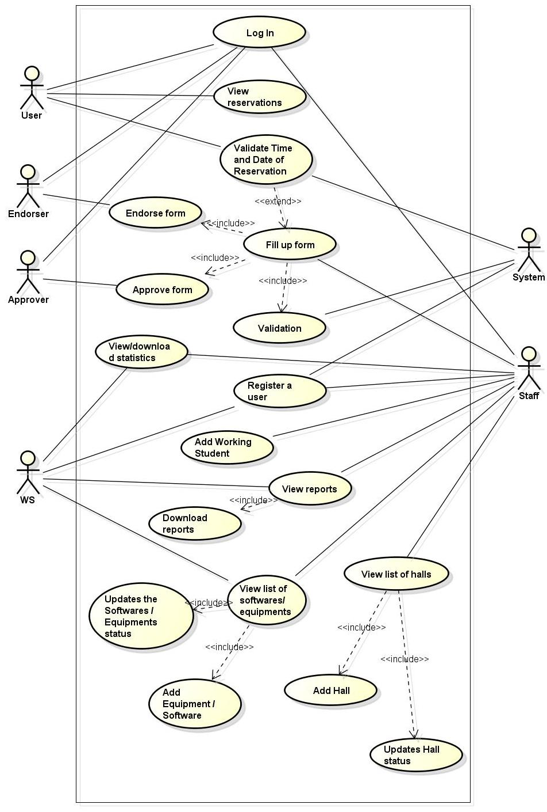

***Figure 4.2.2 High-level Use Case Diagram***

**4.2.3 Entity Relationship Diagram**

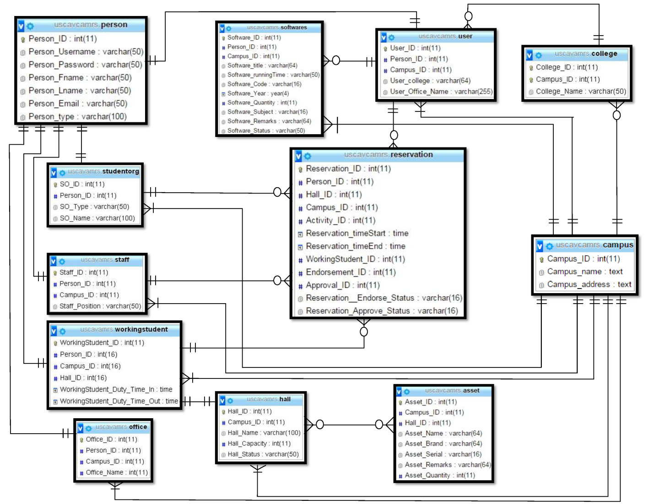

***Figure 4.2.3 Entity Relationship Diagram***

**4.3 Testing and Evaluation**

**Table 4.8 Log in**

|  |  |  |  |  |
| --- | --- | --- | --- | --- |
| **User** | **Input** | **Expected result** | **Actual Result** | **Status** |
| 1. Empty fields | *blank fields | Please fill out the fields |  |  |
| 2. Input Username | Username | Log in success |  |  |
| Username | Invalid username or password |  |  |
| 3. Input password | Password | Log in success |  |  |
| Password | Invalid username or password |  |  |
| 1. Empty fields | *blank fields | Please fill out the fields |  |  |

**Table 4.9 Manage Hall**

|  |  |  |  |  |
| --- | --- | --- | --- | --- |
| **User** | **Input** | **Expected result** | **Actual Result** | **Status** |
| 1. Empty fields | *blank fields | Please fill out the (name of field) field |  |  |
| 2. Hall name | Hall name | Success |  |  |
| 3. Capacity | Integer | Success |  |  |
| Float or Character | Capacity number is invalid |  |  |
| 4. Description | Description | Success |  |  |
| Description | Must be 100 characters |  |  |

**Table 4.10 Manage Software**

|  |  |  |  |  |
| --- | --- | --- | --- | --- |
| **User** | **Input** | **Expected result** | **Actual Result** | **Status** |
| 1. Empty fields | *blank fields | Please fill out the (name of field) field |  |  |
| 2. Call number | Call number | Success |  |  |
| Call number (Number only) | Must have a character |  |  |
| Call number (Characters only) | Must have a number |  |  |
| 3. Software name | Text | Success |  |  |

**Table 4.11 Manage Assets**

|  |  |  |  |  |
| --- | --- | --- | --- | --- |
| **User** | **Input** | **Expected result** | **Actual Result** | **Status** |
| 1. Empty fields | *blank fields | Please fill out the (name of field) field |  |  |
| 2. Quantity | Integer | Success |  |  |
| Float | Must be a whole number |  |  |
| Character | Must be a whole number |  |  |
| 3. Asset Name | Text | Success |  |  |
|  | Text (below 4 characters) | Must be 4 or more characters |  |  |
| 4. Serial number | Text | Success |  |  |
| Text (below 3 characters) | Must be 3 or more characters |  |  |

**Table 4.12 Manage User**

|  |  |  |  |  |
| --- | --- | --- | --- | --- |
| **User** | **Input** | **Expected result** | **Actual Result** | **Status** |
| 1. Empty fields | *blank fields | Please fill out the (name of field) field |  |  |
| 2. First Name | Text | Success |  |  |
| Text (below 2 characters) | Must be 2 characters or more |  |  |
| 3. Last Name | Text | Success |  |  |
| Text (below 2 characters) | Must be 2 characters or more |  |  |
| 4. Username | Text | Success |  |  |
| Text (below 6 characters) | Must be 6 characters or more |  |  |
| 5. Email | Email (valid email) | Success |  |  |
| Email (not valid email) | Email is incorrect |  |  |

**Table 4.13 Change Password**

|  |  |  |  |  |
| --- | --- | --- | --- | --- |
| **User** | **Input** | **Expected result** | **Actual Result** | **Status** |
| 1. Empty fields | *blank fields | Please fill out the (name of field) field |  |  |
| 2. Current Password | Text | Success |  |  |
| Text (below 6 characters) | Must be 6 characters or more |  |  |
| Text (incorrect password) | Incorrect Password |  |  |
| 3. New Password | Text | Success |  |  |
| Text (below 6 characters) | Must be 6 characters or more |  |  |
| 4. Re-type Password | Text | Success |  |  |
|  | Text | Password didn’t match |  |  |

**Table 4.14 Reservation**

|  |  |  |  |  |
| --- | --- | --- | --- | --- |
| **User** | **Input** | **Expected result** | **Actual Result** | **Status** |
| 1. Empty fields | *blank fields | Please fill out the (name of field) field |  |  |
| 2. Others” | Text | Success |  |  |
| Text (below 10 character) | Must be 10 or more characters |  |  |
| 3. Client Software | Text | Success |  |  |